A

MINI PROJECT ||

Report On

**“Resource Sharing Application”**

Submitted In Partial Fulfillment Of The Requirements For The

Degree Of

**Bachelor Of Technology**

**( Semester VI )**

**In**

**Computer Science And Engineering**

SUBMITTED BY

**Tanishk Wagh (2165451242081)**

**Preeti Rajpure (2165451242053)**

**Omkar Wagh (2165451242072)**

**Mandar Shinde (2165451242069)**

Uder the supervision of

**Mrs. Pharande R.S**



Department Of Computer Science And Engineering

ARVIND GAVALI COLLEGE OF ENGINEERING SATARA

**2023-24**

**Certificate**

This is certify that the Mini Project report entitled

**“ Resource Sharing Application”**

is a bonafide work carried out by;

**Tanishk wagh (2165451242081)**

**Preeti RajPure (2165451242053)**

**Omkar wagh (2165451242072)**

**Mandar Shinde (2165451242069)**

Uder Our Supervision During The Year **2023-24** And Submitted To The Faculty Of Computer Science And Engineering , AGCE Satara.

In Partial Fulfilment Of The Requirements For The Award Of The Degree Of **Bachelor Of Technology In Computer Science And Engineering.**

(Alumni Mentor) (Project Guide) (Project Coordinator)

(HOD) (R&D Coordinator) (Principle)

(Internal Examiner) (External Examiner)

**UNDERTAKING**

We hereby declare that the details furnished above are true and correct to the best of our knowledge and belief and we undertake to inform authorities about any changes there in, immediately. In case any of the above information is found to be false or untrue or misleading or misrepresenting, we are aware that we may be held liable for it.

|  |  |  |  |
| --- | --- | --- | --- |
| Sr.No | Name Of Student | Roll No | Sign |
| 1 | Tanishk wagh | 2165451242081 |  |
| 2 | Preeti Rajpure | 2165451242053 |  |
| 3 | Omkar Wagh | 2165451242072 |  |
| 4 | Mandar Shinde | 2165451242069 |  |

Place : Satara

Date :

**Acknowledgement**

It is our privilege to acknowledge my deep sense of gratitude to my guide Mrs.Pharande R.S in Computer Science and Engineering at Arvind Gavali College of Engineering, Satara for his valuable suggestions and guidance throughout our course and the timely help given to us in completion of our project work.

We are thankful to Dr. V. A. Pharande, Principal, Arvind Gavali College of Engineering, Satara and Head of Computer Science and Engineering department for their kind co- operation & moral support.

Finally, we wish to express our sincere thanks to all the staff members of Arvind Gavali College of Engineering, Satara for their direct and indirect help during our project

Place: Satara

Date :

**INDEX**

|  |  |  |
| --- | --- | --- |
| **Sr.No** | **Title Of Chapter** | **Page no** |
| **1** | **Abstract** |  |
| **2** | **Introduction** |  |
| 2.1 | Motivation |  |
| 2.2 | Problem Defination |  |
| 2.3 | Project Scope & Limitations |  |
| **3** | **Literature Survey** |  |
| **4** | **Software Requirements** |  |
| 4.1 | Functional requirements |  |
| 4.2 | Non functional requirements |  |
| 4.3 | Technical requirements |  |
| 4.4 | Analysis Model : V Model |  |
| **5** | **Hardware Requirements** |  |
| 5.1 | Development And Testing Environment |  |
| 5.2 | Production Environment |  |
| **6** | **System Design** |  |
| 6.1 | System architecture |  |
| 6.2 | Data flow diagrams |  |
| **7** | **Advantages and disadvantages** |  |
| **8** | **Conclusion** |  |
| **9** | **Future scope** |  |
| **10** | **Reference** |  |

**ABSTRACT**

Writing notes for exam studies is always not a good option we want more materials to study or prepare for the exams in exam time.

lots of student face problems of getting study material on time and at the one place most of the students create a whatsapp group were they can share there study related material every time but instead of using this.

we have design the application which can help the students to get the study material at the one place and on the time so we have the **Resource Sharing Application** which can helps the students and feel there needs on the time to study properly they can get the materials on one platform so we have best platform than others.

**INTRODUCTION**

Students often face problem while collecting notes and it interrupts their learning process.

Our application will provide a platform for the students where they can come together for collaborative learning. Students can share their notes/materials ( both handwritten and in document - PPT, PDF, DOC, etc. format) to the admin of the website through the whatsapp or Email so the admin can check the notes and add then into the application and the students from any branch or semester from the different universities can access for free.

In our platform users can upload their notes giving a short description and some keywords related to the subject, branch and semester. Other users can search the notes using those keywords which will provide them filtered results. Each user will have an account through they will access the application.

The platform is planned to be a **LEARN| SHARE | EDUCATE** platform which aims to increase effectiveness and conceptual clarity of students.

**LITERATURE REVIEW**

|  |  |  |  |  |
| --- | --- | --- | --- | --- |
| **Sr no** | **Author Name** | **Paper Name** | **Publication Year** | **Technology used** |
| 1 | John smith et al | Notes taking tool | 2015 | This tool is used to take the notes and useful for the students |
| 2 | Emily johnson | Notes sharing application | 2020 | This application is useful to share the notes and save the students time in weasting in the searching the notes |
| 3 | David brown | Notes sharing application | 2019 | In this application the python is used to develop all the functionalities |
| 4 | Rachel lee et al | Notes sharing application | 2020 | This application can used the java as a programming lang for this application |

**Software Requirements**

Creating a resource sharing application involves defining both functional and non-functional requirements. Below is a comprehensive list of software requirements for such a project:

* **Functional Requirements**

1. User Authentication and Authorization

- User registration (email, password, etc.)

- Login and logout functionality

- Role-based access control (admin, user, etc.)

2. User Profile Management

- View and edit personal profiles

3. Resource Management

- Create, edit, and delete resource listings

- Categorize resources (pdf , vedio links, mcq test links etc.)

4. Resource Search and Discovery

- Search resources by keywords, category, location, etc.

- Filter and sort search results

- View resource details

6. Notifications and Alerts

- Email notifications for important actions (request approval, new messages)

- In-app notifications for real-time updates

7. Messaging System

- Direct messaging between users

- Message history and storage

8. Admin Panel

- Manage users and resources

- View and manage system logs

- Handle disputes and issues

* **Non-Functional Requirements**

1. Performance

- Fast load times (under 3 seconds for main pages)

- Efficient search and filtering capabilities

2. Scalability

- Support for a growing number of users and resources

- Ability to scale horizontally (adding more servers)

3. Security

- Data encryption (in transit and at rest)

- Protection against common vulnerabilities (SQL injection )

- Regular security audits

4. Usability

- Intuitive and user-friendly interface

- Mobile responsiveness

5. Reliability

- High availability (99.9% uptime)

- Regular backups and disaster recovery plan

* **Technical Requirements**

1. Front-end Technologies

- HTML, CSS, JavaScript

- Frameworks: javascript

2. Back-end Technologies

- Programming language: php

- Frameworks: javascript

3. Database

- Relational Database: MySQL

4. APIs

- RESTful API for client-server communication

- Third-party APIs for notifications, payments (if applicable)

5. Hosting and Deployment

- Cloud platform: AWS, Google Cloud, or Azure

- Containerization: Docker

- CI/CD tools: Jenkins, GitHub Actions

**HARDWARE REQUIREMENTS**

The hardware requirements for a Resource-sharing application will depend on several factors, including the expected number of users, the complexity of the application, and the scalability plans. Here’s a breakdown of the potential hardware requirements:

* **Development and Testing Environment**

1. Developer Workstations

- Processor: Quad-core CPU (e.g., Intel i5 or AMD Ryzen 5)

- RAM: 16 GB

- Storage: 512 GB SSD

- Network: High-speed internet connection

- Operating System:Windows, macOS, or Linux

2. Local Development Servers (optional)

- Processor: Quad-core CPU

- RAM: 16 GB

- Storage: 512 GB SSD

- Network: High-speed internet connection

* **Production Environment**

1. Web Server

- Processor: 8-core CPU (e.g., Intel Xeon or AMD EPYC)

- RAM: 32 GB or more

- Storage: 1 TB SSD

- Network: Gigabit Ethernet connection

- Operating System:Linux (Ubuntu, CentOS, etc.)

2. Database Server

- Processor:8-core CPU

- RAM: 64 GB or more (dependent on the size of the database and number of concurrent connections)

- Storage: 2 TB SSD (consider NVMe for faster access)

- Network: Gigabit Ethernet connection

- Operating System: windows

3. File Storage Server (for storing uploaded notes)

- Processor: Quad-core CPU

- RAM: 16 GB

- Storage: Configurable based on storage needs (start with 2 TB HDD, scalable)

By carefully planning the hardware requirements and considering future scalability, you can ensure that your note-sharing application will perform well and accommodate growth efficiently.

**System design**

* **System Architecture**

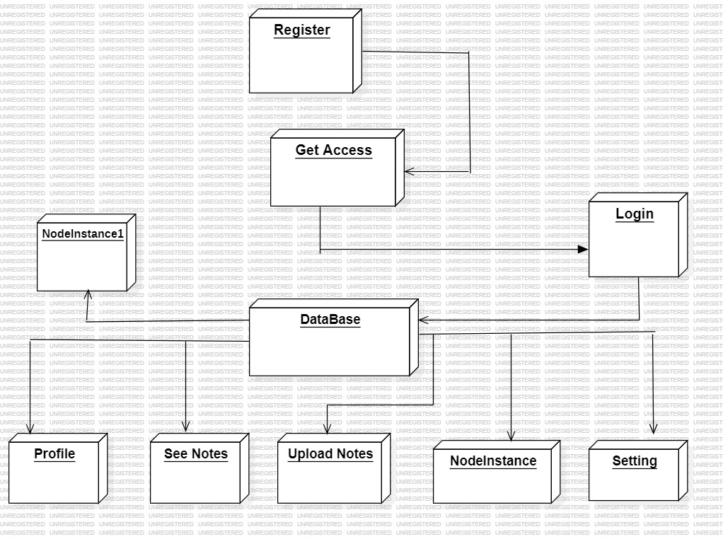

* **Data flow diagram**

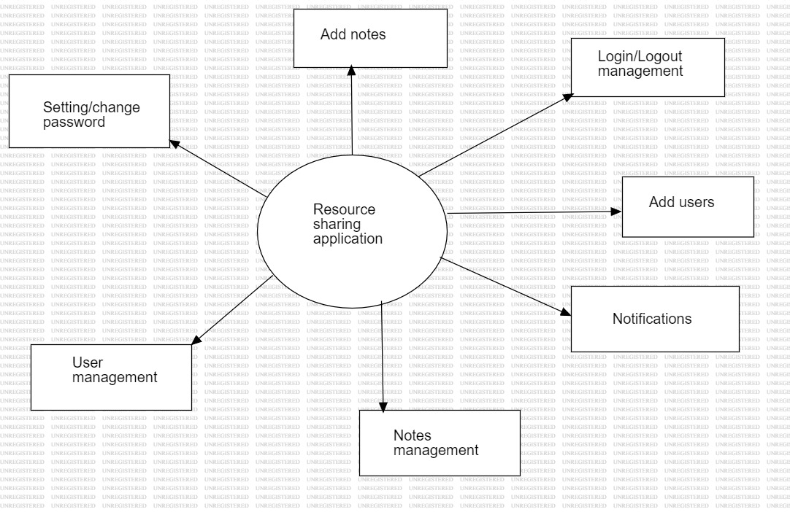

**Fig: ( zero level dfd)**

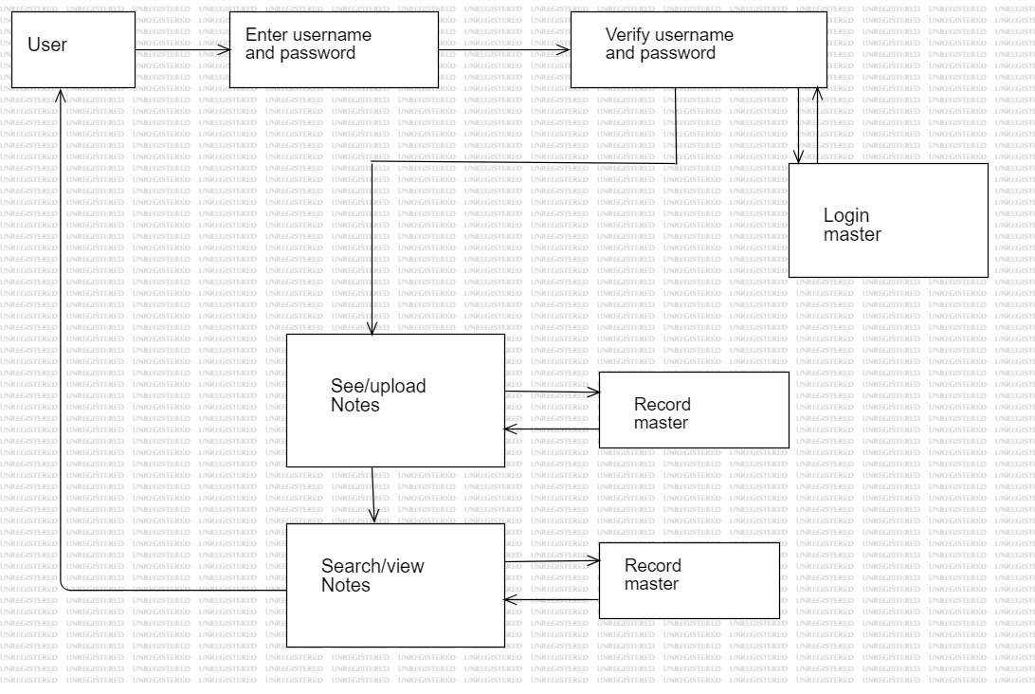

**Fig: ( level 1 Dfd)**

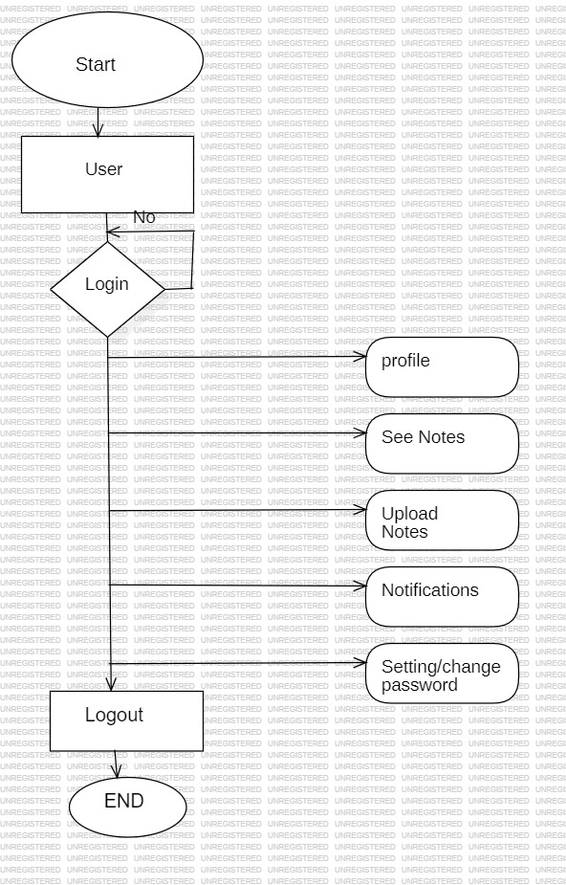

**Fig: (User Side Dfd)**

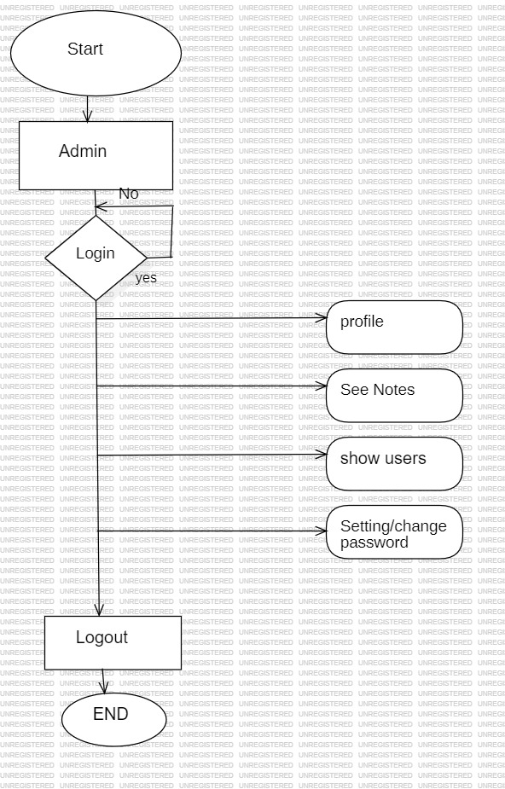

**Fig: ( Admin Side Dfd)**

**ADVANTAGES OR DISADVANTAGES**

**Advantages:**

1. **Collaboration:** Users can easily share and collaborate on notes, enhancing productivity for group projects or study sessions.

2. **Accessibility:** Notes can be accessed from anywhere with an internet connection, allowing users to study or work on the go.

3. **Organization:** Users can organize their notes efficiently with features like tags, folders, and search functions, making it easy to find information.

4. **Version Control:** Some applications offer version control, allowing users to track changes and revert to previous versions if needed.

5. **Synchronization:** Notes are synchronized across devices, ensuring users always have access to the latest updates.

**Disadvantages:**

1. **Privacy Concerns:** Sharing notes can raise privacy concerns, especially if sensitive information is involved.

2. **Dependency on Internet:** Users need an internet connection to access their notes, which can be inconvenient in areas with poor connectivity.

3. **Security Risks:** There's a risk of data breaches or hacking, especially if the application doesn't have robust security measures in place.

4. **Cost:** Some advanced features or storage options may require a subscription or payment, which can be a drawback for budget-conscious users.

5. **Learning Curve:** Users may need time to familiarize themselves with the application's features and interface, potentially impacting initial usability.

**CONCLUSION**

In conclusion, a notes sharing application project offers numerous advantages such as enhanced collaboration, accessibility, organization, version control, and synchronization.

However, it also presents certain disadvantages including privacy concerns, dependency on internet connectivity, security risks, potential costs, and a learning curve for users.

Despite these drawbacks, the benefits of improved collaboration and accessibility often outweigh the challenges, making Resource Sharing Applications valuable tools for individuals and groups seeking to streamline their note-taking and information sharing processes.

**FUTURE SCOPE**

The future scope of a notes sharing application project is promising, with opportunities for further enhancement and innovation. Some potential areas for future development include:

1. **Advanced Collaboration Features:** Introducing real-time collaboration features such as simultaneous editing, chat functionalities, and group discussions can enhance the collaborative experience for users.

2. **Enhanced Security Measures:** Continuously improving security protocols and implementing encryption techniques to safeguard user data and prevent unauthorized access or data breaches.

3. **Integration with AI:** Integrating artificial intelligence capabilities for features like automatic summarization, content recommendations, or smart tagging to improve note organization and accessibility.

4. **Cross-Platform Compatibility:** Ensuring seamless compatibility across various platforms and devices, including desktops, tablets, and mobile devices, to provide users with a consistent experience regardless of the device they use.

5. **Augmented Reality (AR) Integration:** Exploring the integration of AR technology to enable users to interact with their notes in immersive ways, such as virtual study environments or interactive 3D models.

6. **Accessibility Features:** Implementing accessibility features to ensure that the application is usable by individuals with disabilities, such as screen reader compatibility, voice commands, and customizable interfaces.

7. **Machine Learning Algorithms:** Leveraging machine learning algorithms to analyze user behavior and preferences, offering personalized recommendations, and improving the overall user experience.

8. **Blockchain Technology:** Exploring the use of blockchain technology for enhanced data security, transparency, and decentralization, ensuring that user data remains secure and tamper-proof.

By focusing on these areas of development, a Resource sharing application project can stay relevant and competitive in an ever-evolving digital landscape, meeting the evolving needs and expectations of users.

**REFERENCES**

* IJRAMT_V3_I4_4-1.PDF.
* <https://www.researchgate.net/publication/343464430_notes_sharing_application>
* <https://www.scribd.com/document/396271836/Report-Note-Sharing>
* <https://www.studocu.com/row/documents/tribhuvanvishwavidalaya/csit/online-note-share-report-shiv-chaudhary/14511601>